Project Title: AI-Based Localization And Classification Project Design Phase-I - Solution Fit Template Team ID: PNT2022TMID26285 Of Skin Disease With Erythema

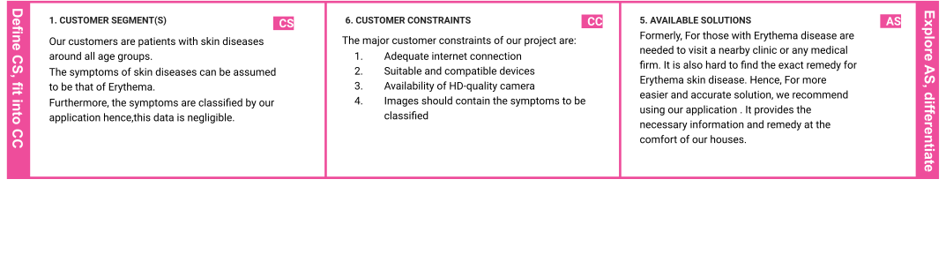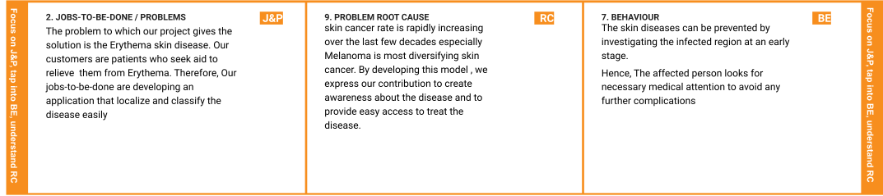

|  |  |  |  |  |  |
| --- | --- | --- | --- | --- | --- |
|  | **3. TRIGGERS** | **TR** | **10. YOUR SOLUTION SL**  To overcome the Erythema disease we are building a model which is used for the prevention and early  detection of skin cancer, psoriasis. Basically, skin disease diagnosis depends on the different  characteristics like color, shape, texture etc. Here the person can capture the images of skin and then the image will be sent to the trained model. The model  analyses the image and detects whether the person is having skin disease or not. | **8.CHANNELS of BEHAVIOR CH** |  |
| If skin diseases are not treated at an earlier |  | **8.1 ONLINE** |
| stage, then it may lead to complications in |  | The patient needs to upload a suitable image ﬁle into the |
| the body including spreading of the infection |  | application. |
| from one individual to the other. This triggers |  |  |
| the patient to consult a specialist |  | **8.2 OFFLINE** |
| immediately. |  | The patient should capture an HD image in an |
|  |  | available camera which acts as the data the model |
|  |  | predicts with. |

|  |  |  |  |  |
| --- | --- | --- | --- | --- |
|  | **4. EMOTIONS: BEFORE / AFTER EM** Before the treatment , the user would feel desperate and in need of help. The disease might also cause them despair.  After using our model, They would feel hopeful and  knowledgeable about what should be done to cure it. |  |  |  |